Angels & Demons!

Summary:

Group activity card game. Involving a group of friends split into two teams. The first team to have a player reach 10 points wins. Each turn is split into two sections: a day-event, where all players elect a player to receive 1 point, and a night-event, where a solitary player draws and plays an action card. Players will need a combination of subterfuge, charisma, trust, and luck to achieve victory.

Overview:

* Objective: be the team with the first player to reach 10\* points.
* 4-10\* players, split into 2 teams: Angels, and Demons.
* Mobile device used as a “deck” to be passed from one player to the next each turn.
* Initial set-up round will assign players a team and a villager identity.
* Players take turns, each turn is composed of a day-event and a night-event
* Day-event: all players debate and elect a single player to receive 1\* point.
* Night-event: player with the mobile device draws an action card and plays it

Lore:

Locked in their eternal struggle, Angels and Demons find themselves trapped in the bodies of villagers in a remote town. In order to return to heaven, they must gain the trust of the other villagers and curry points of Favor to become the village Elect – but they must remain wary, as the identities of friend and foe have obfuscated and even their most trustworthy ally may be an opponent in hiding.

How to play:

Similar to “Mafia,” players should arrange themselves to sit in a circle facing each other.

After clicking “Play Now!” on the mobile device, the screen will shift to show the “Set Up Menu.” Here players can adjust the number of players, and the # of points needed to win (or other options). Clicking “Start” will leave behind the Set Up Menu and bring up the Set Up Round.

During the Set Up Round, players pass the Mobile device around each taking a night-event turn. Each player will see themselves assigned a team allegiance, Angel or Demon (private information), as well as a villager identity (public information). They will also draw an Action card and play it.

There are 10 villager identities, they are doled out at random, and have no gameplay effect other than to assign a player an identity (and I guess role play):

Fisherman, Smith, Farmer, Shepherd, Hunter, Craftsman, Scholar, Apothecary, Warrior, Bard, Noble

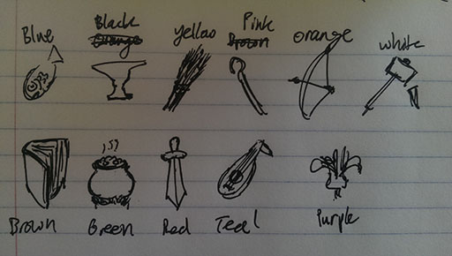

Action cards (heavily subject to change):

Steal! (take 1 favor from any player, give yourself 1 favor)

Curse! (take 1 favor from any player)

Bless! (give 1 favor to any player)

Spy! (choose 1 player, see their identity)

Guard! (block the next 1 favor a player will lose)

Disgrace! (block the next 1 favor a player will receive \*includes points given during day-event)

Reveal! (all player scores become visible to player for 1 turn)

\*maybe players can choose to spend 1 of their own points to redraw once per turn?

The Set-Up round allows the game to assign players their teams and identities, and also allows the scoreboard to variate a little so the day events can be interesting.

Once all players are done taking their Set-Up turns, the regular game begins. The Mobile device continues to be passed from one player to the next at the end of each turn. When a player is finished with their turn, the screen will cloud up and prompt a “Next Player Ready?” message so as to keep the previous player’s information private.

Each turn is composed of a day event and a night event.

During the day event all players will discuss and elect 1 person to receive 1 favor. The device will display all player identity icons arranged in a circle, and the player holding the device will tap the icon that is chosen by consensus (this should be done in plain view). \*Could play like mafia, where two nominees must be put up, and they each have to give some kind of speech to persuade the others. \*\*Possible balance: if we find that games with an even number of players always results in tied votes, could consider disallowing the player holding the device from voting.

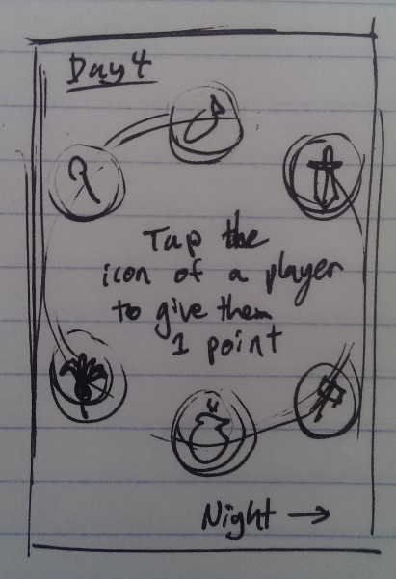

During the night event all players put their heads down (and don’t peek!) and the player holding the device will see a display that shows all player icons arranged in a circle (but their identities are clouded) and their respective scores. \*\*\*IMPORTANT: A PLAYER IS ONLY SHOWN THE SCORES OF THOSE WITH A GREATER OR EQUAL SCORE TO HIM/HERSELF (all other scores are clouded).

In the center of the circle is a randomly drawn Action card, which the player must play in order to complete his turn. Each action card is associated with a sound (ie. the Steal! card might play a coin-jingle) alerting all other players to what action was just performed (this will bring impetus to argument during the next day event). An end turn button on the bottom of the screen will end the turn when pressed.

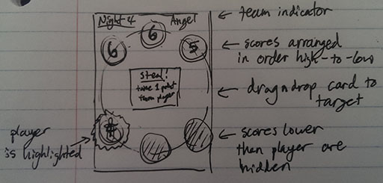

This process goes on until a player achieves 10 favor. \*\*\*IMPORTANT: A PLAYER CAN ONLY GET THE 10th POINT BY BEING ELECTED FROM THE DAY EVENT (a player cannot win by receiving a point during a night event). After which the screen will display “Angels Exalted!” or some such celebratory message to indicate that the game is over. And the option to go back to the main menu will appear.